Temperature Sensor Tutorial/troubleshooting

Talia Spitz Spring 2019

# Probe

The probe for the temperature sensor is covered in epoxy in order to waterproof it. It is the only part of the sensor which should be immersed in water.

## Manufacturing

### Parts list for the probe:

|  |  |  |  |
| --- | --- | --- | --- |
| Part | Amount | Notes | Image |
| Custom temp board | 1 | you can find the board schematic at: https://www.dropbox.com/sh/mgy3ndqnzldy1xk/AABXH-txk6h3GChvCx_p5i7ma?dl=0 |  |
| Digital temp sensor | 1 | Part number: AT30TS750A-SS8M-T, Digikey |  |
| 10 kΩ resistor, 1206 | 1 | Part number: RC1206FR-0710KL, Digikey |  |
| 0.1 μF capacitor, 1206 | 1 | Part number: 478-5724-1-ND or 399-4674-1-ND, Digikey |  |
| 4-pin header | 1 | Part number: WM9131-ND, Digikey |  |
| Wire | 4 (different colors) | By convention, we use black, red, purple, and white. In later manufacturing, we use ribbon wire. |  |
| MG Chemicals epoxy | 1 | Part number: 832TC-450ML  <https://www.amazon.com/MG-Chemicals-Thermally-Conductive-Encapsulating/dp/B008UH4CRM#product-description-iframe> |  |

### Steps:

1. Firstly, you’ll want to attach the wires to the connector. Crimp them in place by hand first, then solder them in. When you’re done, carefully push them into the plastic case, and snap off the metal tag. It’s easy to break the wires while you’re doing this, so be gentle. If it’s needed, you can ***carefully*** use a pair of pliers to push the wires in.

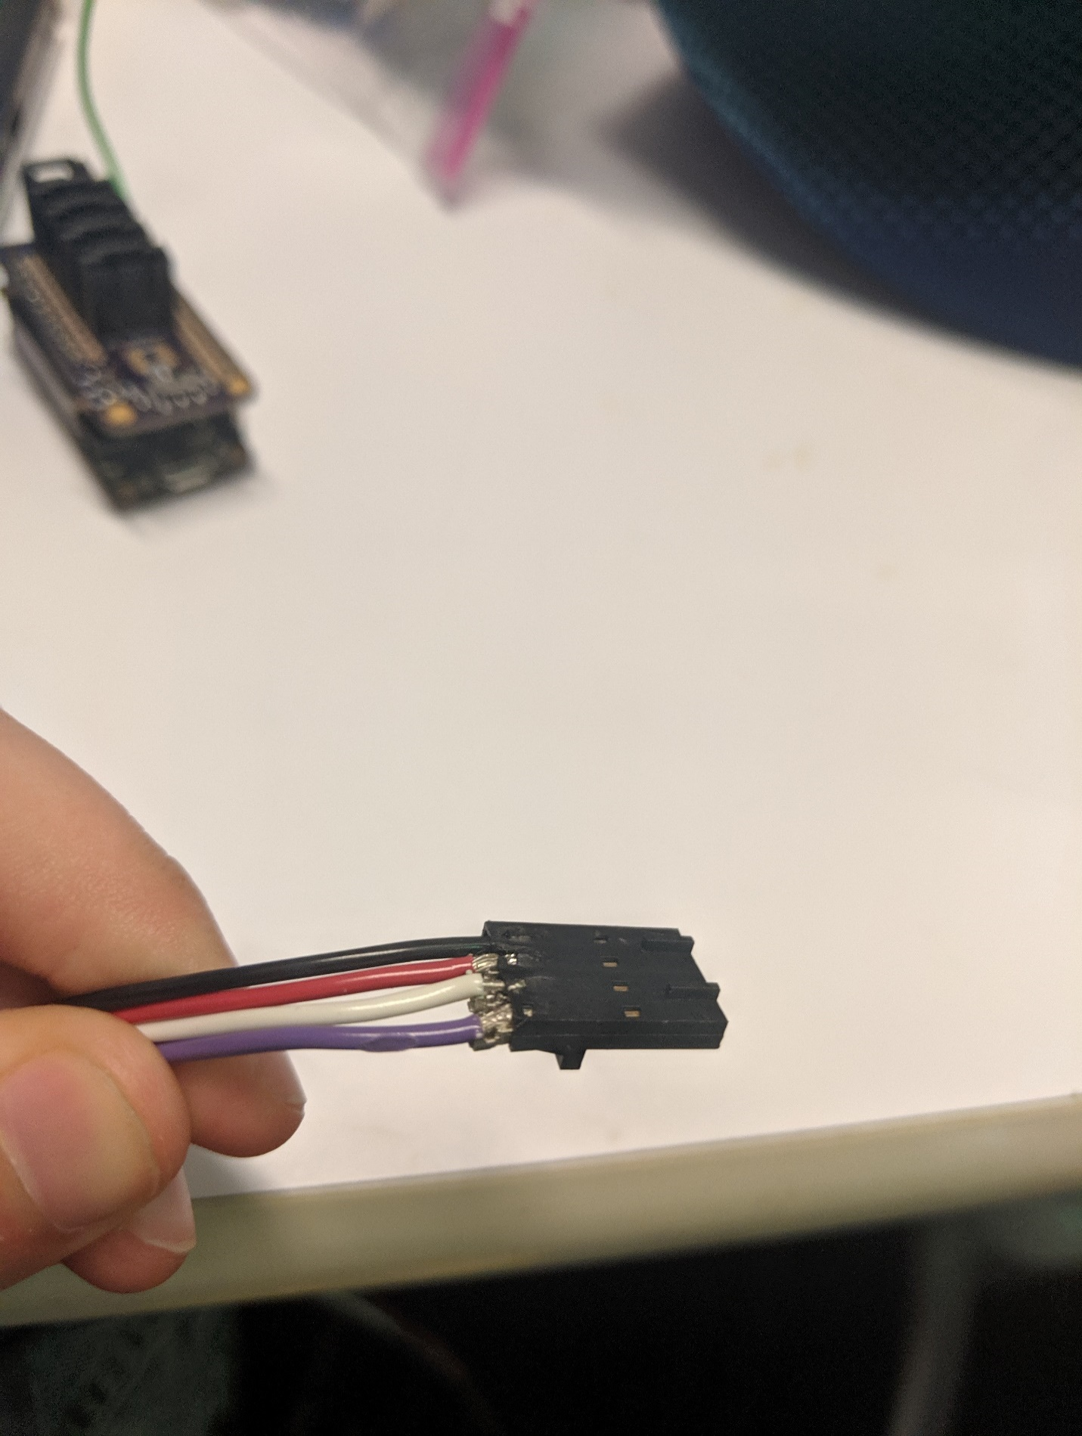

The finished connection.

1. Follow the board schematic and solder on the resistor, capacitor, and temperature sensor.

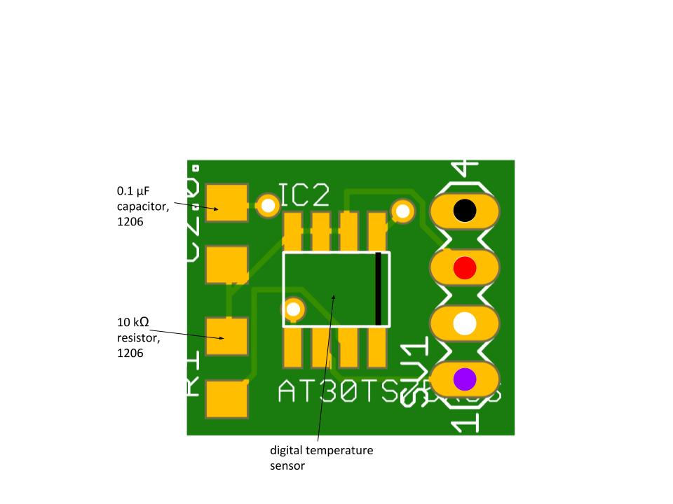

Annotated temperature circuit board schematic.

1. Solder the wires to their corresponding pins.
2. **Test to see if the sensor works before epoxying it!!** Follow the directions on the epoxy containers to waterproof the probe. The epoxy should cover the whole circuit board and up the wires a little bit.

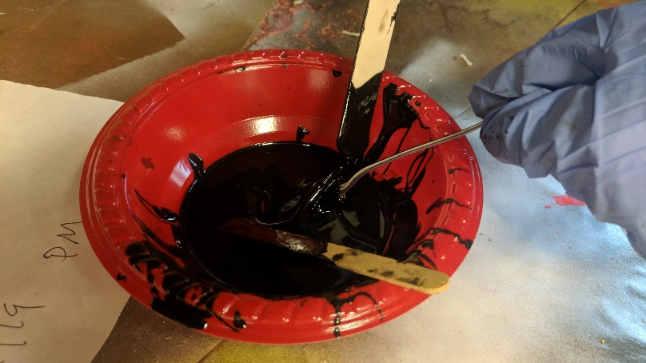

First dip the board into the epoxy, then use a popsicle stick to spread the epoxy up the wires and make sure the entire board is coated. Once you’re sure it’s covered, gently scrape off excess epoxy so it doesn’t drip while it cures.

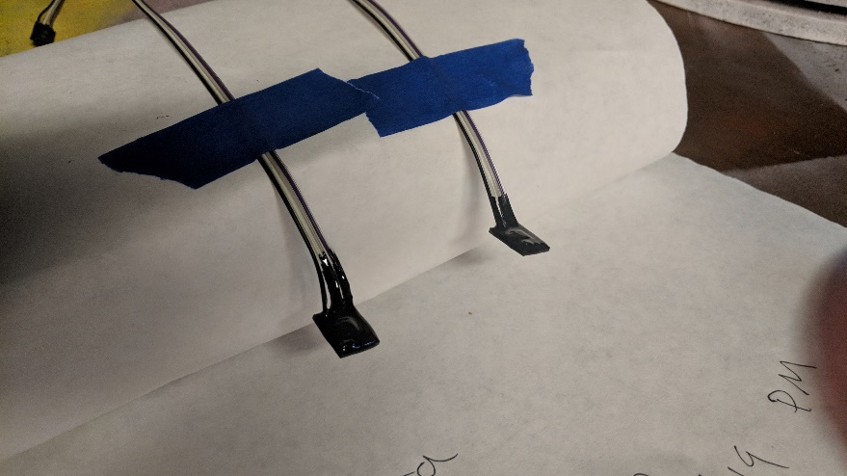

Leave the epoxied sensors to cure for 24 hours. Check them after a couple of hours to see if you need to touch up any areas with more epoxy, or if you need to scrape off any more excess.

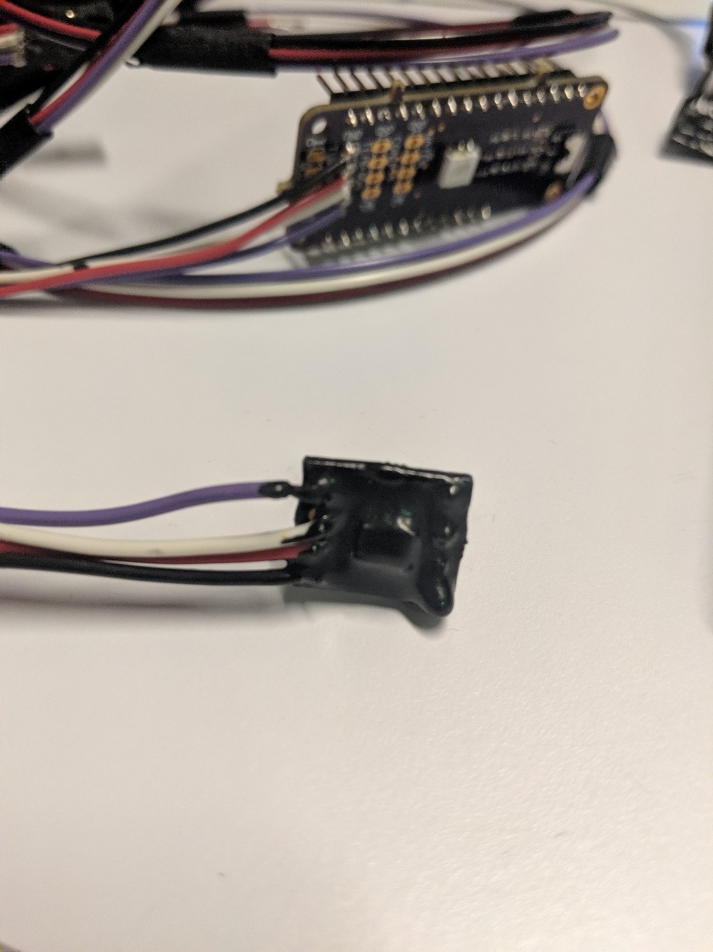

The cured epoxy (black) should look like this.

# troubleshooting

To test if your temperature sensor is working, plug it into the Feather, and run the ‘tempWire’ (found at: “GitHub\seeboat\software\testing\temperature\tempWire\tempWire.ino”) file in Arduino. The serial monitor should print the temperature reading in both Celsius and Fahrenheit.